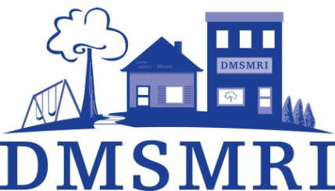 | Daniel McIntyre St. Matthews Revitalisation Inc.  2021 - 22 Community Small Grants Final Report

If needed, feel free to use a separate page or attach additional information. If you have questions about this report or want help filling it out, call the Small Grants Coordinator at 774-7005 ext. 102.

Name of Project: _____________________________________________________________

Project Start Date: ______________________ Project End Date: _____________________

What was the impact of your project on the community? What changes came about as a result?

Identify the participants, committees, groups involved in carrying out your project.

How many participants were served by your project? ________
How many volunteers assisted with putting on your project? _______
As per the application form, can you demonstrate that at least 60% of the participants were residents of St. Matthews or Daniel McIntyre neighbourhoods and 90% from a Neighbourhoods Alive! designated neighbourhood?

Is there anything else you would like to note about your project ?

Please include a detailed expense report for the project listing all costs and revenue. You can use the table below or attach a separate sheet. Copies of receipts are required.

Project Expenses |  | Project Revenue
Total: |  | Total:

Is there anything that we can improve with our Small Grants Program ?

Name and signature of project contact(s):

Contact 1: _____________________________________________________________________

Contact 2: _____________________________________________________________________

Please submit a printed copy with signatures to housing@dmsmri.ca or  Attention Small Grants Coordinator  Daniel McIntyre St. Matthews Revitalisation Inc.  823 Ellice Avenue, Winnipeg, MB R3G 0C3 | DMSMRI’s Community Small Grants Program is supported by:

