2020 DMSMRI Community
Small Grants Application Form

The Daniel McIntyre / St. Matthews Revitalization Inc. Community Small Grants program was established in 2007 to support smaller projects that meet a need in the community and help connect residents with each other. They are available to organizations located within, or that serve, the Daniel McIntyre and St. Matthews neighbourhoods of Winnipeg.
Individuals who wish to apply will have to partner with a community organization. Our sister organization, the Daniel McIntyre / St. Matthews Community Association, may be a good match. We can put you in touch with someone there if you would like.

Grant amounts range from $500 to a maximum of $5,000 in a single year.
Projects must address one or more of the following Neighbourhood Renewal Fund categories and involve as much public and volunteer participation as possible:

- Capacity Building: outreach activities such as consultations, newsletters and community meetings.

- Neighbourhood Stability: Beautification activities such as community gardens, murals and clean-ups.

- Well-being: Social and recreational activities such as festivals and afterschool activities.

- Community Economic Development: Skill building activities, training, and/or employment/volunteer development.

Other Requirements

- At least 60% of the participants must be residents of the St. Matthews and Daniel McIntyre neighbourhoods, (see the map on the next page for our boundaries), and 90% of participants must be from a Neighbourhoods Alive! neighbourhood. (These include West Broadway, Spence, Chalmers, Centennial and the North End.)
Because of this residency requirement, projects located outside the boundaries of Daniel McIntyre and St. Matthews or that operate city-wide are usually not funded.

- Projects must benefit the community and show community support. Letters of support can be included with your application.

- Projects should only require modest, short-term funding.

- Projects involving the use of private or public property must include written permission from the property owner(s).

- Applicants must demonstrate they have the capacity to administer the program.

- Projects and organizations must be in good standing with DMSMRI to receive a Community Small Grant. (For instance, outstanding final reports from previous grants must have been submitted and approved by the Small Grants Coordinator.)

There are some costs that cannot be covered by our Community Small Grants. They include:
- Subsidizing regular salaries. They can, however, be used to pay honoraria to an instructor or cover the wages of a part time staffer during the hours that the programming is taking place.
- Capital items, such as machinery, computers or furniture.
- Improvements to private property unless that property has been made available free-of-charge for community use and the improvements impact the broader community.

To Apply:

Please fill out the attached application and submit it to our Grants Coordinator.

Applicants will be required to make a brief face-to-face presentation to the DMSMRI Small Grants Committee. This should take no more than ten minutes. When you submit your application the Grants Coordinator will let you know the date(s) of the meetings.

Successful applicants will receive a cheque for 80% of the grant amount at the start of the project and the final 20% of upon the submission of a final report, including receipts.

To discuss your project further, or if you need assistance filling out this form, contact the DMSMRI Small Grants Coordinator at housing@dmsmri.ca or 204-775-7005 extension 102.
DEADLINE: Due to the uncertainty of programming this year, we are having monthly intakes instead of one big deadline for the year. Contact our Grants Coordinator to find out more.
DMSMCA Boundaries:

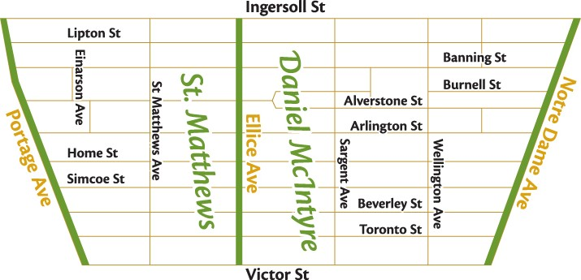

2020 DMSMRI Community Small Grants Application Form
Please complete in full

Name of project: ________________________________________________________________
Name of applicant(s): ________________________________________________________________

Mailing address: ________________________________________________________________

Contact Person
Name:
Phone:
Email:
Second Contact Person
Name:
Phone:
Email:

Describe the Project:

Expected start and end dates, (it must end by March 16, 2021): ___________________________
Grant amount requested, (maximum $5,000 for one calendar year): $ ________________

What community need does this project address and how have you determined that need?

What do you hope will be the impact of this project on the community?
How will you know that this change has been achieved?

Explain how your project fits in one or more of the categories described on the front page:
- Capacity Building - Neighbourhood Stability - Well-being - Economic Development

How will the project be administered and by whom? Identify participants, committees, groups, etc., that will be involved.

Does the project use private or public property? _____ If yes, please attach permission to use it.

Please include a proposed budget for the project, listing the projected expenses and sources of revenue. You can use the table below or attach a separate document.
*Note: successful applicants will be required to submit receipts for expenses with their final report.

Project Expenses |  | Project Income (including other grants)
Item | Amount | Source | Amount
Total: |  | Total:
How many participants do you expect will participate in this project? _______
At least 60% of participants must be residents of the St. Matthews or Daniel McIntyre neighbourhoods and 90% of from any Neighbourhoods Alive designated neighbourhoods. How will you ensure this?

Please demonstrate below or with attached documentation that this project has the support of local residents, (i.e. letters of support, preliminary sign-up sheet, a list of interested participants).

If you receive a grant, how will you acknowledge this funding from DMSMRI? (i.e: display our logo, mention us in presentations or published material, etc.)

______________________________________ _____________________________
Applicant’s signature and Title 2nd Contact Person

Please submit a copy with signatures to:
Small Grants Co-ordinator
Attention : Christian Cassidy
Daniel McIntyre St. Matthews Revitalisation Inc.
823 Ellice Avenue
Winnipeg, MB R3G 0C3
housing@dmsmri.ca

For DMSMRI use only
Date received: ___________________
Grant requested: ___________________ Grant approved: ________________
Grant award date: ___________________
Approved by Committee Rep: _____________ Date approved: ________________

